Fire
This is the ontological representation of Toronto’s fire emergency service, including both fire station service sites and run-area catchment geometries. Fire services are represented as instances of a fire service class (e.g., tor:fire_service{RUN_AREA}), and each service is linked to a catchment area representing the fire run area using service:hasCatchmentArea. Catchment areas are represented as spatial regions with geospatial geometry stored as WKT using geo:asWKT. Fire stations are represented as service sites linked from the fire service via hp:providedFromSite, where each station can have a name (genprop:hasName), an address (org:siteAddress with street components), and a point location (loc:hasLocation) expressed as WKT geometry (geo:asWKT).
To model service performance and capacity, the mapping represents fire service capacity and usage using quantitative rate objects with ISO measurement structure (i72:hasValue, i72:hasNumericalValue, i72:hasUnit). Capacity and capacity-in-use are asserted using res:hasCapacity and res:capacityInUse, and available capacity can be asserted directly using res:hasAvailableCapacity to preserve the classification of the available capacity type (e.g., available firefighters-per-population).
This section summarizes how the Toronto Fire Services run areas dataset (catchment geometries), the fire station locations dataset (service sites and addresses), and the synthetic firefighter-per-person dataset (service usage and derived available capacity) are mapped into the City Digital Twin ontology.

The following is a list of namespace prefixes used in the mappings and ontology definitions that follow:
- tor: http://ontology.eil.utoronto.ca/Toronto/Toronto#
- genprop: https://standards.iso.org/iso-iec/5087/-1/ed-1/en/ontology/GenericProperties/
- loc: https://standards.iso.org/iso-iec/5087/-1/ed-1/en/ontology/SpatialLoc/
- geo: http://www.opengis.net/ont/geosparql#
- hp: http://ontology.eil.utoronto.ca/HPCDM/
- service: https://standards.iso.org/iso-iec/5087/-2/ed-1/en/ontology/CityService/
- change: https://standards.iso.org/iso-iec/5087/-1/ed-1/en/ontology/Change/
- time: http://www.w3.org/2006/time#
- res: https://standards.iso.org/iso-iec/5087/-1/ed-1/en/ontology/Resource/
- i72: http://ontology.eil.utoronto.ca/ISO21972/iso21972#

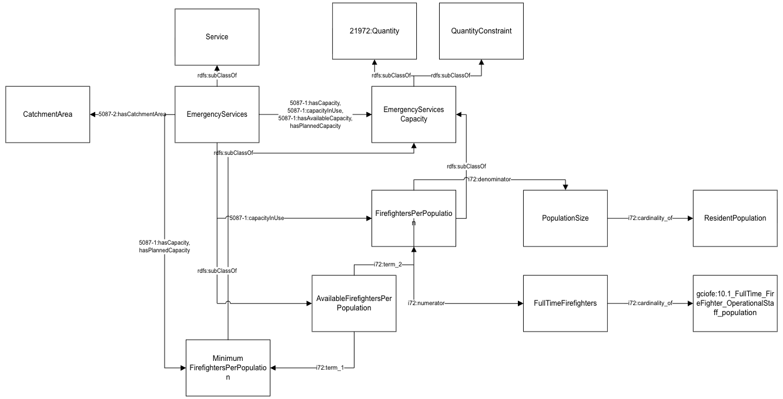
Figure 1: Diagram of Fire Pattern.

Data Provided by Fire Services Run Areas Dataset
Field Name | Subject | Property | Object | Notes
RUN_AREA | tor:fire_service{RUN_AREA} | rdf:type | tor:TorFireEmergencyService | This corresponds to the fire station id and integrates with the fire station dataset; this station will be the primary responder (but others could respond as required)
 | tor:fire_service{RUN_AREA} | service:hasCatchmentArea | tor:fire_catchment_{AREA_ID}
AREA_ID | tor:fire_catchment_{AREA_ID} | genprop:has Identifier | "{AREA_ID}" | Note - there are other attributes for the area (not required)
geometry | tor:fire_catchment_{AREA_ID} | geo:asWKT | {geometry} | Geometry.
Table 1: Mapping Fire Services Run Areas Data to City Digital Twins

Data Provided by Fire Facility Locations Dataset
Field Name | Subject | Property | Object | Notes
STATION | tor:fire_service{STATION} | hp:providedFrom Site | tor:fire_station_{STATION} | Identifier/name for the station
 | tor:fire_station_{STATION} | genprop:hasName | Fire Station {STATION}
 | tor:fire_service{STATION} | rdf:type | hp:FireEmergencyService
ADDRESS_POINT_ID | tor:fire_station_{STATION} | org:siteAddress | tor:fire_station_address_{ADDRESS_POINT_ID} | N/A
 | tor:fire_station_address_{ADDRESS_POINT_ID} | rdf:type | contact:Address
ADDRESS_NUMBER | tor:fire_station_address_{ADDRESS_POINT_ID} | contact:hasStreetNumber | {ADDRESS_NUMBER} | Street address of the station
LINEAR_NAME_FULL | tor:fire_station_address_{ADDRESS_POINT_ID} | contact:hasStreetName | {LINEAR_NAME} | Note: may need to split name with type
geometry | tor:fire_station_{STATION} | loc:hasLocation | tor:fire_station_loc_{ADDRESS_POINT_ID} | Point location of the station
 | tor:fire_station_loc_{ADDRESS_POINT_ID} | geo:asWKT | {geometry} | <- defined via service level numbers (per capita)
 | tor:fire_services | rdf:type | org:Organization
 |  | cdt:providesService | tor:emergency_service
 | tor:fire_service{STATION} | res:hasCapacity | tor:fire_service{STATION}Capacity
 | tor:fire_service{STATION}Capacity | rdf:type | hp:MinFirefighterPerPopulation
 | tor:fire_service{STATION}Capacity | i72:hasValue | tor:fire_service{STATION}CapacityMeasure
 | tor:fire_service{STATION}CapacityMeasure | i72:hasNumericalValue | 0.001
 | tor:fire_service{STATION}CapacityMeasure | i72:hasUnit | i72:population_ratio_unit
Table 2: Mapping Fire Facility Locations Data to City Digital Twins

Data Provided by Synthetic firefighter population counts Dataset
Field Name | Subject | Property | Object | Notes
RUN_AREA | tor:fire_service{RUN_AREA} | res:capacityInUse | tor:fire_service{RUN_AREA}CapacityUse | <- to generate (approximation of staffing count to population ratio)
 | tor:fire_service{RUN_AREA}CapacityUse | rdf:type | hp:FirefighterPerPopulation
 | tor:fire_service{RUN_AREA}CapacityUse | i72:hasValue | tor:fire_service{RUN_AREA}CapacityUseMeasure
Firefighters per person in run area | tor:fire_service{RUN_AREA}CapacityUseMeasure | i72:hasNumericalValue | {Firefighters per person in run area}
 | tor:fire_service{RUN_AREA}CapacityUseMeasure | i72:hasUnit | i72:population_ratio_unit
 | tor:fire_service{RUN_AREA} | res:hasAvailableCapacity | tor:fire_service{RUN_AREA}AvailCapacity
 | tor:fire_service{RUN_AREA}AvailCapacity | rdf:type | hp:AvailableFirefightersPerPopulation
 | tor:fire_service{RUN_AREA}AvailCapacity | i72:hasValue | tor:fire_service{RUN_AREA}AvailCapacityMeasure
 | tor:fire_service{RUN_AREA}AvailCapacityMeasure | i72:hasNumericalValue | 0.001 - {Firefighters per person in run area}
 | tor:fire_service{RUN_AREA}AvailCapacityMeasure | i72:hasUnit | i72:population_ratio_unit
Table 3: Mapping Synthetic firefighter population counts Data to City Digital Twins
- Capacity information:
  - No count of firefighters per station (catchment area)
  - Toronto-wide: est.84% of 3191 = 2680 full time firefighters
    - This could be captured as a “capacity in use” metric of the actual ratio, however it is not worthwhile encoding this as it is too general to be useful for the use cases
- There is the potential to link each catchment area to a specific fire station (corresponding to a sub-service of tor:emergency_service), however this is not

Implementation of Fire Data in Mapping TTL
Script: Fire.py
URI strategy
The script generates deterministic URIs under the tor: namespace so that run areas, stations, and capacity measures can be referenced consistently:
- Fire service (run area): tor:fire_service{RUN_AREA}
- Run area catchment polygon: tor:fire_catchment_{AREA_ID}
- Fire station site: tor:fire_station_{STATION}
- Station address node: tor:fire_station_address_{ADDRESS_POINT_ID}
- Station location node: tor:fire_station_loc_{ADDRESS_POINT_ID}
- Station capacity rate and measure:
  - tor:fire_service{STATION}Capacity
  - tor:fire_service{STATION}CapacityMeasure
- Run area capacity-in-use rate and measure:
  - tor:fire_service{RUN_AREA}CapacityUse
  - tor:fire_service{RUN_AREA}CapacityUseMeasure
- Run area available capacity rate and measure:
  - tor:fire_service{RUN_AREA}AvailCapacity
  - tor:fire_service{RUN_AREA}AvailCapacityMeasure
Inputs
- Run areas (catchment geometry)
  - toronto-fire-services-run-areas - 4326.csv
  - Required fields used:
    - RUN_AREA (for service URI construction)
    - AREA_ID (for catchment URI + identifier)
    - geometry (GeoJSON / coordinates converted to WKT)
- Fire station locations (service sites + addresses)
  - fire-station-locations - 4326.csv
  - Required fields used:
    - STATION (for station URI construction)
    - ADDRESS_POINT_ID (for address/location URIs)
    - ADDRESS_NUMBER (street number)
    - LINEAR_NAME_FULL (street name; code also checks a fallback column name)
    - geometry (GeoJSON / coordinates converted to WKT)
- Synthetic usage data (capacity-in-use)
  - synthetic firefighter and population counts(in).csv
  - Required fields used:
    - RUN_AREA
    - Firefighters per person in run area
Outputs
- fire.ttl
Contains: run area fire services, catchment polygons (with WKT), fire station sites (names, addresses, point geometries), and station-level capacity assertions.
- fire_synthetic.ttl
Contains: run-area capacity-in-use assertions and explicit available-capacity assertions derived from the synthetic dataset.
Step-by-step process
Step 1 - Initialize RDF graph and namespaces
A graph is created and namespaces are bound (e.g., tor, hp, genprop, geo, service, org, contact, loc, cdt, res, i72).
Step 2 - Normalize geometries and convert to WKT
Helper functions infer geometry types (when missing) and convert stored geometry values into WKT using shapely, so geometries can be asserted via geo:asWKT.
Step 3 - Map run areas as fire services with catchment polygons
For each row in toronto-fire-services-run-areas - 4326.csv:
- Create tor:fire_service{RUN_AREA} and assert it as a fire emergency service class.
- Link the service to a catchment resource tor:fire_catchment_{AREA_ID} using service:hasCatchmentArea.
- Add an identifier to the catchment (genprop:hasIdentifier).
- Convert the run area polygon geometry to WKT and assert it with geo:asWKT.
Step 4 - Map fire stations as service sites
Before iterating stations, the script also asserts a few “global” triples to connect an organization to the emergency service.
For each row in fire-station-locations - 4326.csv:
- Create a station site tor:fire_station_{STATION} and add a name (genprop:hasName).
- Link the station as a site using hp:providedFromSite.
- Create an address node tor:fire_station_address_{ADDRESS_POINT_ID} and attach street number/name when present.
- Create a location node tor:fire_station_loc_{ADDRESS_POINT_ID} and assert point WKT geometry using geo:asWKT.
Step 5 - Assert service capacity
For each station, the script asserts a capacity node:
- tor:fire_service{STATION} res:hasCapacity tor:fire_service{STATION}Capacity
- The capacity node is typed as hp:MinFirefighterPerPopulation.
- The measure node stores:
  - i72:hasNumericalValue (constant 0.001)
  - i72:hasUnit i72:population_ratio_unit
Step 6 - Map synthetic usage and explicitly assert available capacity
From synthetic firefighter and population counts(in).csv, for each RUN_AREA:
- Assert res:capacityInUse with a node typed hp:FirefighterPerPopulation and a measure storing the usage value.
- Assert res:hasAvailableCapacity with a node typed hp:AvailableFirefightersPerPopulation.
- Compute available capacity as (0.001 - capacityInUse) and store it as the measure’s numerical value (using the same unit).
Step 7 - Serialize TTL outputs
Serialize the run area + station graph to fire.ttl.
- Serialize the synthetic usage graph to fire_synthetic.ttl.
Notes / assumptions
- Geometry values may be stored without an explicit GeoJSON "type" field; the script attempts to infer the geometry type from coordinates before conversion to WKT.
- The station capacity is currently asserted on tor:fire_service{STATION}, while capacity-in-use and available capacity are asserted on tor:fire_service{RUN_AREA}. If you need available capacity to strictly represent (hasCapacity − capacityInUse) on the same service instance, these assertions should be aligned to the same service URI (e.g., all at the run-area service).
- The value 0.001 is a configured constant in the script; it should be replaced if/when validated capacity definitions are available.

